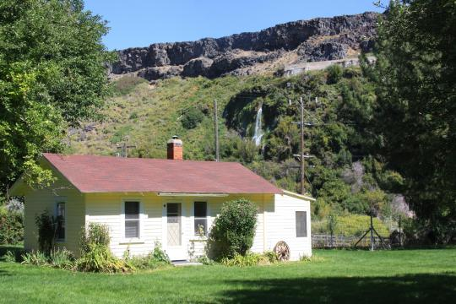  - yellow House  The Yellow House features a fully equipped kitchen, 1 bathroom, and 1 bedroom plus a hide-a-bed, which can accommodate up to 4 overnight guests. You can spend your evenings grilling on the outside gas BBQ or just spend your evening relaxing with spectacular views of the crystal-clear springs.  To make reservations, contact Reserve America at www.reserveamerica.com or call 888-922-6743. Fees are $86 per night ($95 per night for out of state residence) with a 2-night minimum. There is a $100 refundable cleaning deposit due prior to your arrival date. | Stay on the Island!  Fully Equipped Kitchen  Great Views  Newly refurbished  Clean and comfortable  BBQ Grill  Thousand springs state park  1074 E 2350 S  Hagerman, ID 83332  208.837.4505  www.parksandrecreation.idaho.gov

