DELUXE CABINS AT PONDEROSA STATE PARK
The following fees apply to all deluxe cabin reservations.
There is a 2-night minimum stay per reservation.
$10.00 Reservation Fee (per cabin) plus tax
$100.00 Cleaning/Damage Deposit (per reservation) *

For Peak Season stays May 1st -September 30th in Bear, Wolf, Fox, and Moose
Idaho Resident $160.00 per night plus tax
Non- Idaho Resident $175.00 per night plus tax

For Peak Season stays May 1st -September 30th in Elk, Eagle, Owl, Mule Deer, and Whitetail
Idaho Resident $181.00 per night plus tax
Non- Idaho Resident $200.00 per night plus tax

For Non-Peak Season stays October 1st – April 30th in Bear, Wolf, Fox, and Moose
Excluding weekends and Holidays
Idaho Resident $110.00 per night plus tax
No-Idaho Resident $125.00 per night plus tax

For Non-Peak Season stays October 1st – April 30th in Elk, Eagle, Owl, Mule Deer, and Whitetail
Excluding weekends and Holidays
Idaho Resident $131.00 per night plus tax
Non- Idaho Resident $150.00 per night plus tax

*Cleaning/Damage Deposit is paid direct to the park.
The Cleaning/Damage Deposit and a completed Overnight Agreement form are required to be on file with the park prior to the arrival date.

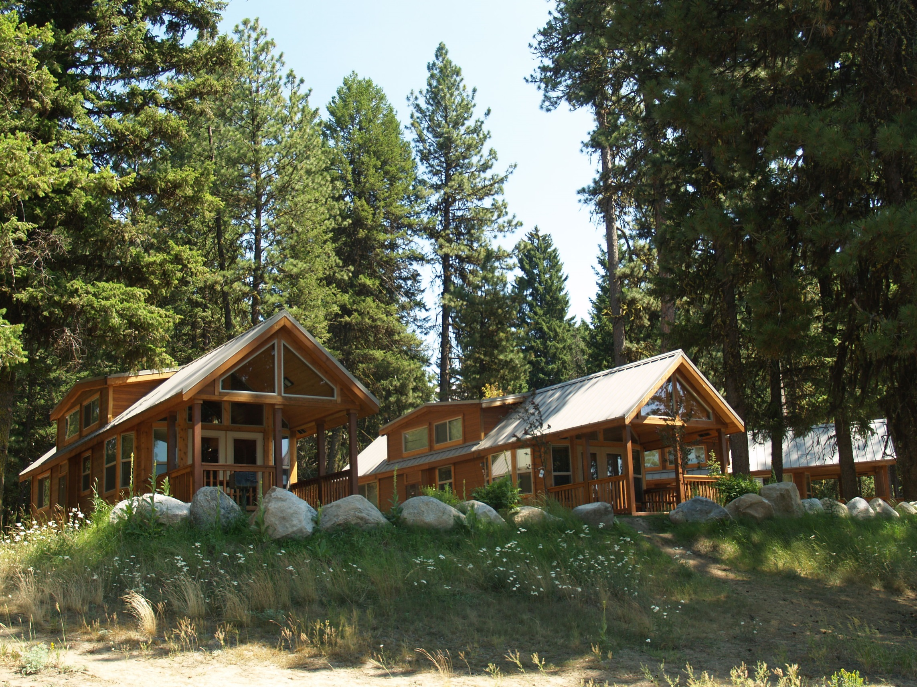

Want to see what dates are available?
Visit our web site at www.parksandrecreation.idaho.gov

Are you ready to make your cabin reservation?
Call toll free 1-888-922-6743

Need more information?
Call the park at 208-634-2164
View photos on our Facebook page at
www.facebook.com/PonderosaStatePark

.
Ponderosa State Park has nine cabins nestled along the shore of Payette Lake. These cabins come with a full-size refrigerator, stove/ oven, microwave, and dishwasher. The kitchens also include; cookware, bakeware, dinnerware, utensils, cups, coffee maker, toaster, and so much more. The bedrooms and bathrooms come stocked with blankets, sheets, and towels.
Mule-Deer—Sleeps 4 It’s ADA accessible with a ramp leading to the door. It has an open floor plan. There is a queen size bed and a fold out sofa that is queen size as well. The bathroom has a full tub with a fold down bench.
Moose—Sleeps 5 It’s ADA accessible with a ramp leading to the door. There is a pass-through bathroom complete with a roll in shower that leads to the main bedroom which has a queen size bed. There are two twin beds in the loft. Customers are permitted to bring an air mattress, to be placed in the loft, in order to accommodate sleeping compacity.
Bear, Wolf Fox--- Sleep 6 These all have the same floor plan with a queen size bed and two twin beds in the loft. Customers are permitted to bring an air mattress, to be placed in the loft, in order to accommodate sleeping compacity.
Eagle, Owl, White-tail---Sleep 6 These cabins are single level with two bedrooms. One bedroom has one queen size bed, and the other bedroom has one queen size bed and one full size bed.
Elk—Sleeps 8 This cabin is the largest with vaulted ceilings. On the main level is a bedroom with a queen size bed and a queen size fold out sofa. The loft has partial privacy with a queen size bed tucked behind a wall and a queen size futon that is out in the open.

The cabins are reservable year-round. Reservations are accepted nine months in advance of the date you would like to arrive with a two-night minimum. You can book no less than two days prior to your arrival date. Availability can be viewed at www.parksandrecreation.idaho.gov ; to make reservations call1-888-922-6743.
Cabin fees accommodate only one (1) Motor Vehicle Entrance Fee, additional vehicles must pay $5 per night upon arrival at the park. All vehicles must the park in the designated cabin parking areas nearby.
Additional camping equipment or awnings will not be permitted at the cabins.
Pets are not allowed at the cabins.
Check in is after 3:00 pm on your arrival date; check out is by 12:00 pm on your departure date.

